Citi Guide

Supervisor. | Miss Amna Sattar
Batch. | 2305B1
Group. | A
Serial No. | Enrollment Number | Student Name
1. | Student1473958 | Rayyan Hassan
2. | Student1462259 | M.Sahib Akber
3. | Student1462726 | Mussab Ahmed Khan
4. | Student1473372 | Syeda Shaher Bano
5. | Student1477218 | Syed Hasan Ahmed
6. | Student 1477205 | Raiba
7. | Student1442888 | Madiha Khan

APP WIRE FRAMES

1.LOGIN (ADMIN and USER)
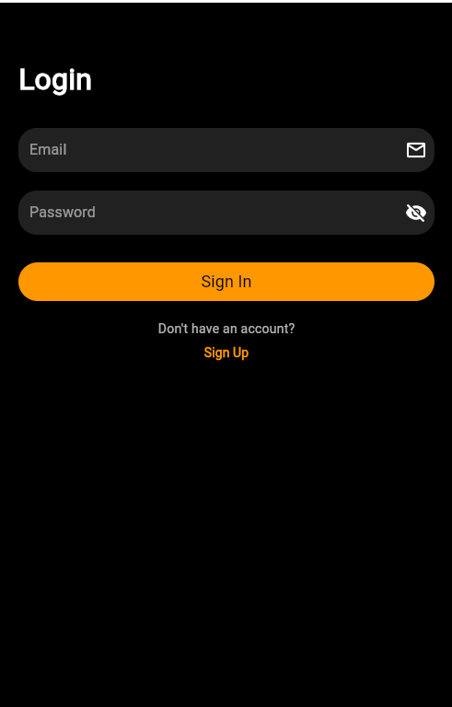
2.SIGNUP (USER and ADMIN)
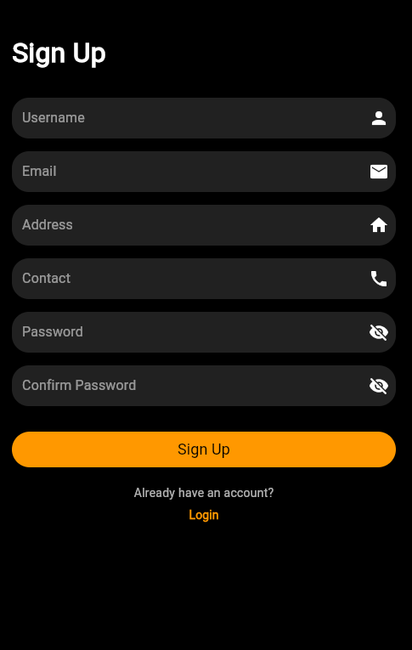

3.USER PROFILE (ADMIN)
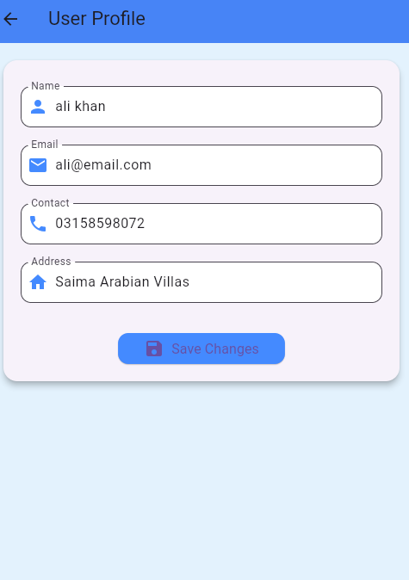

4.Display city (ADMIN)
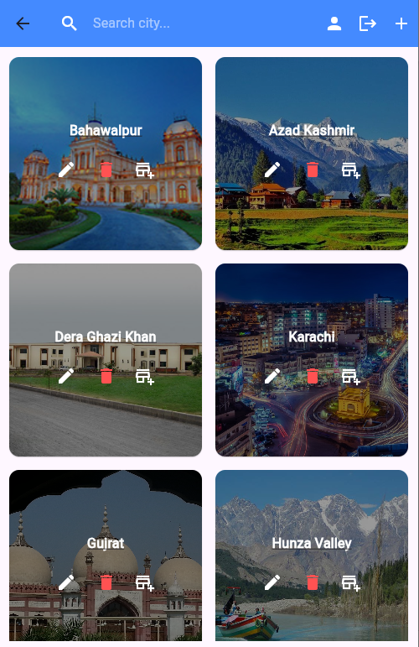

5.ADD CITY (ADMIN)
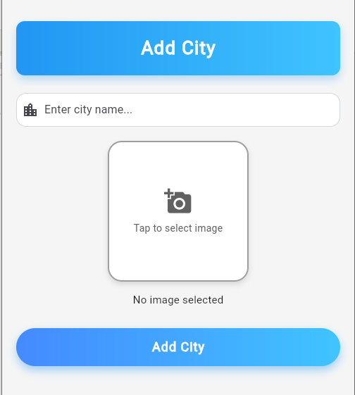
6. Add Attraction (ADMIN)
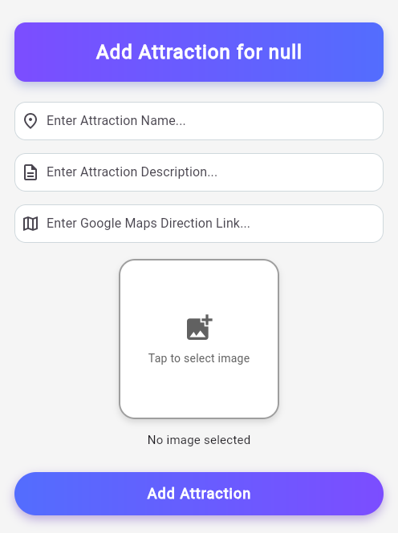

7.Attraction Display and Single Page View (Dart)
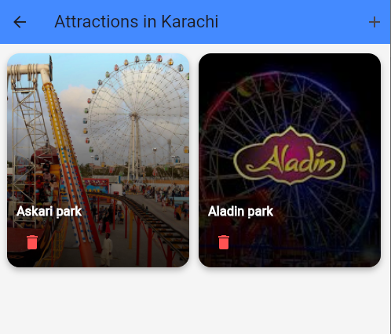

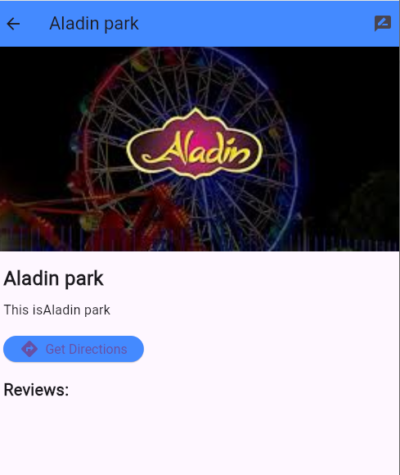

8.Search Functionality
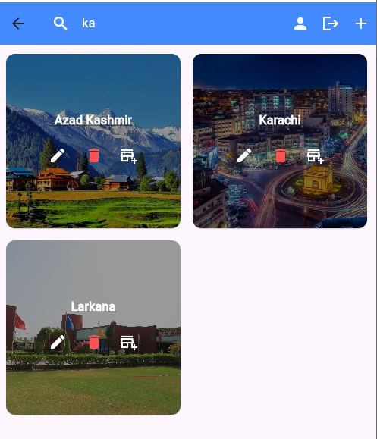

9.Display City (USER)
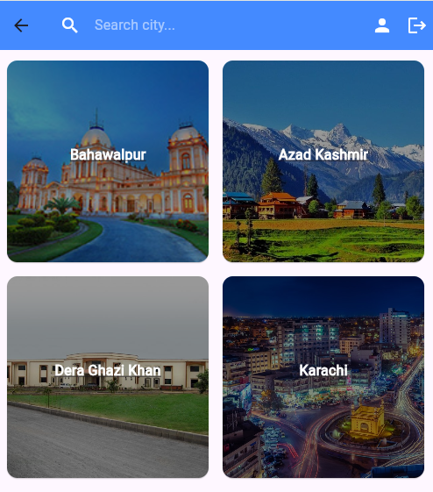
10.Attraction Display (User)
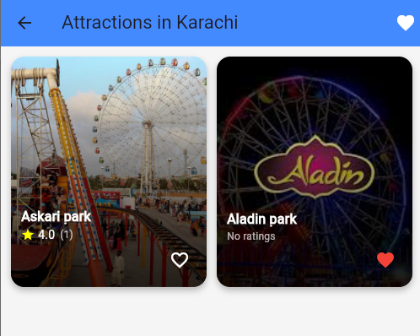
11.Single Page View (USER)
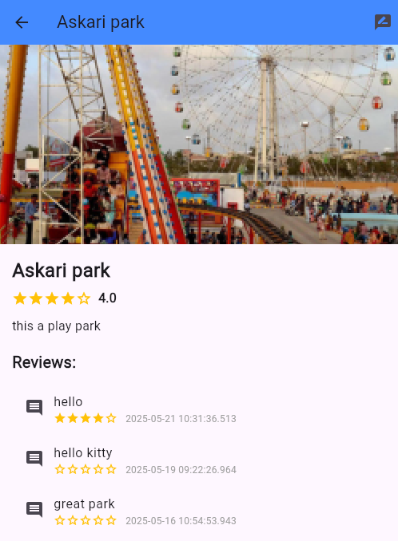
12.Reviews and Ratings
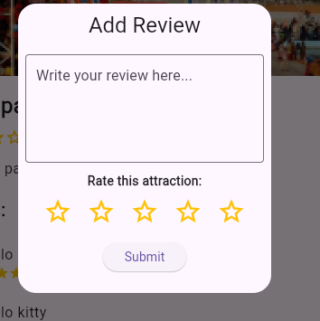
13.Favourite Attractions (USER)
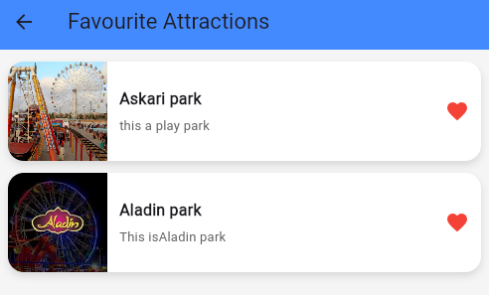

14. Data in firebase
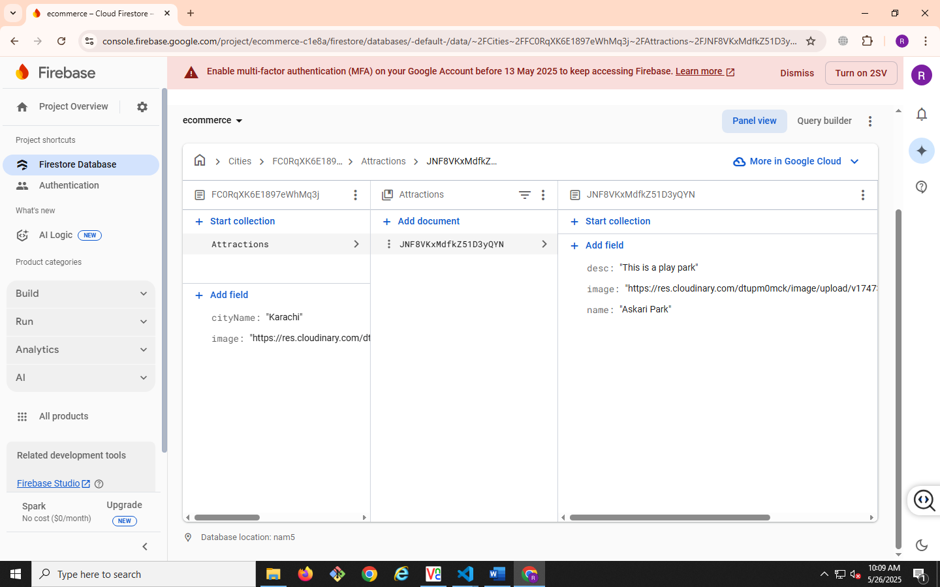

TASK SHEET REVIEW

Ref. No.: eP/Advertisement Portal Management  System/01 |  | Project title | Date of Preparation of Activity Plan
No | Task | CITI GUIDE | Actual | Actual | Team-mate | Status
No | Task | CITI GUIDE | Start Date | Days | Names | Status
1 | Deciding | CITI GUIDE | 24/04/2025 | 2 | All team mates | Complete
1 | Themes
2 | Connection of project with firebase | CITI GUIDE | 27/04/2025 | 1 | Rayyan Hassan | Complete
3 | Finding images and collection of Data | CITI GUIDE | 28/04/2025 | 3 | Madiha Khan  S.Shaher Bano | Complete
4 | Authentication of user and admin pannel | CITI GUIDE | 01/05/2025 | 5 | Rayyan Hassan  Raiba | Complete
5 | Add City and Display city in admin | CITI GUIDE | 07/05/2025 | 3 | Rayyan Hassan | Complete
6 | Search Functionality And Admin Profile |  | 11/04/2025 | 1 | Rayyan Hassan | Complete
7 | Making the crud enable in admin | CITI GUIDE | 13/05/2025 | 4 | Rayyan Hassan | Complete
8 | Add review in attraction |  | 18/05/2025 | 2 | Rayyan Hassan | Complete
9 | Making login and logout and registration system on dash board |  | 21/05/2025 | 1 | Rayyan Hassan | Complete
10 | Enhance the UI of project |  | 22/05/2025 | 1 | Rayyan Hassan | Complete

TASK SHEET REVIEW

Project Ref. No.: eP/Advertisement Portal Management  System/01 |  | Project title | Date of Preparation of Activity Plan
No | Task | CITI GUIDE | Actual | Actual | Team-mate | Status
No | Task | CITI GUIDE | Start Date | Days | Names | Status
1 | Documentation | CITI GUIDE | 23/05/2025 | 1 | M.Sahib Akber  Syed Hasan | Complete
2 | Design Document of the project | CITI GUIDE | 24/05/2025 | 1 | Mussab Khan  S.Shaher Bano | Complete

